UNITED STATES
SECURITIES AND EXCHANGE COMMISSION
Washington, D.C. 20549

FORM 8-K

CURRENT REPORT
Pursuant to Section 13 or 15(d) of the Securities Exchange Act of 1934

Date of Report (Date of earliest event reported): October 20, 2026

Clearway Energy, Inc.
(Exact name of registrant as specified in its charter)

Delaware |  | 001-36002 |  | 46-1777204
(State or other jurisdiction of  incorporation) |  | (Commission File Number) |  | (IRS Employer Identification No.)

902 Carnegie Center, Suite 520, Princeton, New Jersey 08540
(Address of principal executive offices, including zip code)

(609) 608-1525
(Registrant’s telephone number, including area code)

N/A
(Former name or former address, if changed since last report)

Check the appropriate box below if the Form 8-K filing is intended to simultaneously satisfy the filing obligation of the registrant under any of the following provisions:

☐ | Written communications pursuant to Rule 425 under the Securities Act (17 CFR 230.425)

☐ | Soliciting material pursuant to Rule 14a-12 under the Exchange Act (17 CFR 240.14a-12)

☐ | Pre-commencement communications pursuant to Rule 14d-2(b) under the Exchange Act (17 CFR 240.14d-2(b))

☐ | Pre-commencement communications pursuant to Rule 13e-4(c) under the Exchange Act (17 CFR 240.13e-4(c))

Securities registered pursuant to Section 12(b) of the Act:

Title of each class | Trading Symbol(s) | Name of each exchange on which registered
Class C Common Stock, par value $0.01 | CWEN | New York Stock Exchange

Indicate by check mark whether the registrant is an emerging growth company as defined in Rule 405 of the Securities Act of 1933 (§230.405 of this chapter) or Rule 12b-2 of the Securities Exchange Act of 1934 (§240.12b-2 of this chapter).

Emerging growth company ☐

If an emerging growth company, indicate by check mark if the registrant has elected not to use the extended transition period for complying with any new or revised financial accounting standards provided pursuant to Section 13(a) of the Exchange Act. ☐

Item 2.02 | Results of Operations and Financial Condition.

On October 20, 2026, Clearway Energy, Inc. (the “Company”) released a presentation containing certain operational data for the three and nine months ended September 30, 2026, with respect to its renewable energy and flexible generation fleet (the “Operational Update Presentation”). The Operational Update Presentation is available on the Company’s website, www.clearwayenergy.com, on the “Presentations and Webcasts” page under the “Investor Relations” tab. A copy of the Operational Update Presentation is furnished as Exhibit 99.1 to this Current Report on Form 8-K and is incorporated herein by reference. Information on the Company’s website is not incorporated by reference into, and does not constitute a part of, this Current Report on Form 8-K.

In accordance with General Instruction B.2 of Form 8-K, the information set forth in this Item 2.02 and in the attached exhibit are deemed to be furnished and shall not be deemed to be “filed” for purposes of Section 18 of the Securities Exchange Act of 1934, as amended (the “Exchange Act”), or otherwise subject to the liabilities of that section, nor shall such information be deemed incorporated by reference into any filing under the Securities Act of 1933, as amended, or the Exchange Act, unless specifically identified therein as being incorporated therein by reference.

Item 9.01 | Financial Statements and Exhibits.

 | (d) | Exhibits

Exhibit  No. |  | Document
99.1 |  | Clearway Energy, Inc. Operational Update Presentation, dated October 20, 2026
104 |  | Cover Page Interactive Data File (formatted as inline XBRL and contained in Exhibit 101).

SIGNATURES

Pursuant to the requirements of the Securities Exchange Act of 1934, the registrant has duly caused this report to be signed on its behalf by the undersigned hereunto duly authorized.

 | Clearway Energy, Inc.
 | By: | /s/ Michael A. Brown
 |  | Michael A. Brown
 |  | Senior Vice President, General Counsel and Corporate Secretary
Dated: October 20, 2026

Exhibit 99.1

 | 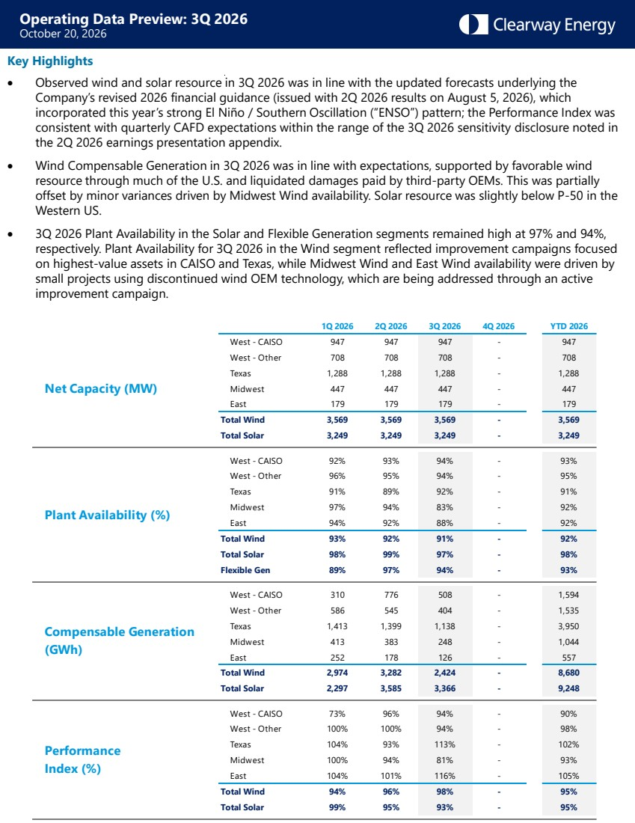 | Operating Data Preview: 3Q 2026 October 20, 2026 1Q 2026 2Q 2026 3Q 2026 4Q 2026 YTD 2026 West - CAISO 947 947 947 - 947 West - Other 708 708 708 - 708 Texas 1,288 1,288 1,288 - 1,288 Midwest 447 447 447 - 447 East 179 179 179 - 179 Total Wind 3,569 3,569 3,569 - 3,569 Total Solar 3,249 3,249 3,249 - 3,249 West - CAISO 92% 93% 94% - 93% West - Other 96% 95% 94% - 95% Texas 91% 89% 92% - 91% Midwest 97% 94% 83% - 92% East 94% 92% 88% - 92% Total Wind 93% 92% 91% - 92% Total Solar 98% 99% 97% - 98% Flexible Gen 89% 97% 94% - 93% West - CAISO 310 776 508 - 1,594 West - Other 586 545 404 - 1,535 Texas 1,413 1,399 1,138 - 3,950 Midwest 413 383 248 - 1,044 East 252 178 126 - 557 Total Wind 2,974 3,282 2,424 - 8,680 Total Solar 2,297 3,585 3,366 - 9,248 West - CAISO 73% 96% 94% - 90% West - Other 100% 100% 94% - 98% Texas 104% 93% 113% - 102% Midwest 100% 94% 81% - 93% East 104% 101% 116% - 105% Total Wind 94% 96% 98% - 95% Total Solar 99% 95% 93% - 95% Net Capacity (MW) Plant Availability (%) Compensable Generation (GWh) Performance Index (%) Key Highlights • Observed wind and solar resource in 3Q 2026 was in line with the updated forecasts underlying the Company’s revised 2026 financial guidance (issued with 2Q 2026 results on August 5, 2026), which incorporated this year’s strong El Niño / Southern Oscillation (“ENSO”) pattern; the Performance Index was consistent with quarterly CAFD expectations within the range of the 3Q 2026 sensitivity disclosure noted in the 2Q 2026 earnings presentation appendix. • Wind Compensable Generation in 3Q 2026 was in line with expectations, supported by favorable wind resource through much of the U.S. and liquidated damages paid by third-party OEMs. This was partially offset by minor variances driven by Midwest Wind availability. Solar resource was slightly below P-50 in the Western US. • 3Q 2026 Plant Availability in the Solar and Flexible Generation segments remained high at 97% and 94%, respectively. Plant Availability for 3Q 2026 in the Wind segment reflected improvement campaigns focused on highest-value assets in CAISO and Texas, while Midwest Wind and East Wind availability were driven by small projects using discontinued wind OEM technology, which are being addressed through an active improvement campaign.
 | 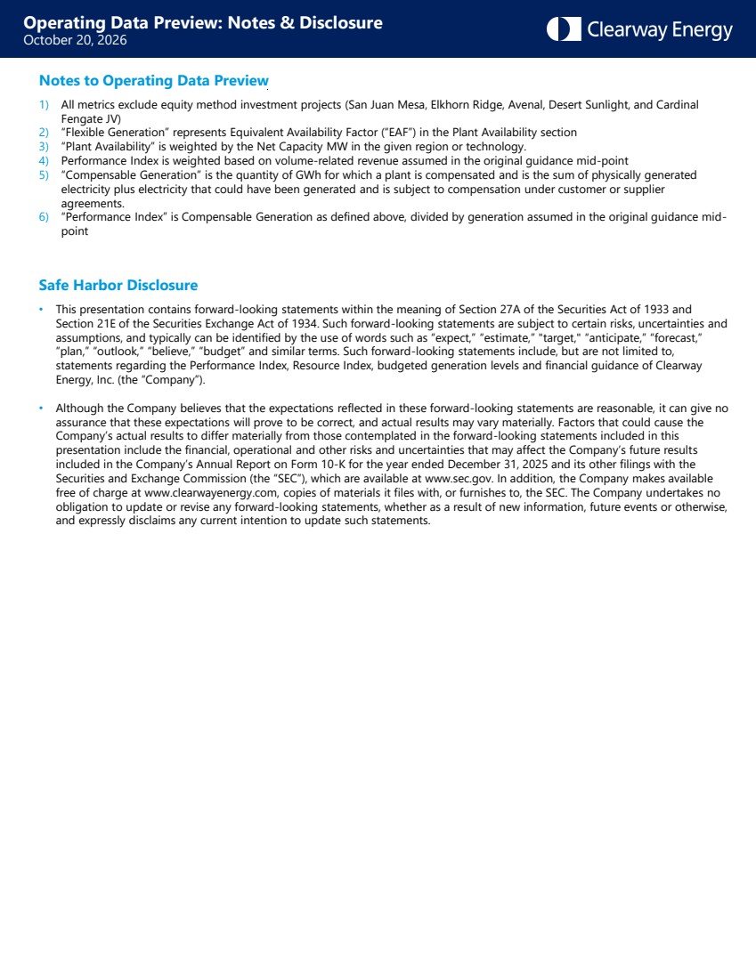 | Operating Data Preview: Notes & Disclosure October 20, 2026 Notes to Operating Data Preview 1) All metrics exclude equity method investment projects (San Juan Mesa, Elkhorn Ridge, Avenal, Desert Sunlight, and Cardinal Fengate JV) 2) “Flexible Generation” represents Equivalent Availability Factor (“EAF”) in the Plant Availability section 3) “Plant Availability” is weighted by the Net Capacity MW in the given region or technology. 4) Performance Index is weighted based on volume-related revenue assumed in the original guidance mid-point 5) “Compensable Generation” is the quantity of GWh for which a plant is compensated and is the sum of physically generated electricity plus electricity that could have been generated and is subject to compensation under customer or supplier agreements. 6) “Performance Index” is Compensable Generation as defined above, divided by generation assumed in the original guidance mid-point Safe Harbor Disclosure • This presentation contains forward-looking statements within the meaning of Section 27A of the Securities Act of 1933 and Section 21E of the Securities Exchange Act of 1934. Such forward-looking statements are subject to certain risks, uncertainties and assumptions, and typically can be identified by the use of words such as “expect,” “estimate,” "target," “anticipate,” “forecast,” “plan,” “outlook,” “believe,” “budget” and similar terms. Such forward-looking statements include, but are not limited to, statements regarding the Performance Index, Resource Index, budgeted generation levels and financial guidance of Clearway Energy, Inc. (the “Company”). • Although the Company believes that the expectations reflected in these forward-looking statements are reasonable, it can give no assurance that these expectations will prove to be correct, and actual results may vary materially. Factors that could cause the Company’s actual results to differ materially from those contemplated in the forward-looking statements included in this presentation include the financial, operational and other risks and uncertainties that may affect the Company’s future results included in the Company’s Annual Report on Form 10-K for the year ended December 31, 2025 and its other filings with the Securities and Exchange Commission (the “SEC”), which are available at www.sec.gov. In addition, the Company makes available free of charge at www.clearwayenergy.com, copies of materials it files with, or furnishes to, the SEC. The Company undertakes no obligation to update or revise any forward-looking statements, whether as a result of new information, future events or otherwise, and expressly disclaims any current intention to update such statements.

